**THIS SECTION IS FOR FACULTY INFORMATION ONLY. DELETE THIS SECTION BEFORE PUBLISHING YOUR SYLLABUS.**

**This Template is for In Person Courses Only**

Templates for other course types can be found on the [CTLED website](https://sites.google.com/gatewaycc.edu/ctled/educators/course-resource-templates)

**INSTRUCTOR NOTES:**

* This syllabus template contains all required elements to meet MCCCD & GateWay requirements. Please consult [MCCCD Administrative Regulation 3.6](https://district.maricopa.edu/regulations/admin-regs/section-3/3-6) before removing any portion of this template as well as for additional information related to syllabi requirements
* To prepare a final syllabus, the entire syllabus must be reviewed and updated in various places to accurately reflect the course details. All items shown in brackets {example} require attention by the instructor prior to finalizing and publishing the syllabus
* Instructors are encouraged to add any additional information they feel is relevant and beneficial to the course and/or students. A compendium of commonly used, optional syllabus statements can be found on the same [CTLED website](https://sites.google.com/gatewaycc.edu/ctled/educators/course-resource-templates) as the syllabi templates. Instructors are encouraged to review and consider incorporating these as appropriate.
* The items marked **Inclusive Syllabus Tips/Samples** may increase students’ sense of belonging and increase the likelihood of their success in your course.
* If you have any questions on this subject, please contact the CTLED or your program leadership for assistance. The CTLED can be contacted by email at [ctl@gatewaycc.edu](mailto:ctl@gatewaycc.edu), by phone at 602.286.8901 or at our offices in the Main building across from the print center (MA 1240).
* Should you find an error or typo on this template, please let us know.

Revision Date: July 2023

**DELETE THIS SECTION BEFORE PUBLISHING YOUR SYLLABUS.**



**{Course Title}**

**Required Textbook(s):** {Add Citation & ISBN}

**Required Materials:** {Exclude line if not applicable}

**Recommended Textbook(s):** {Add Citation & ISBN. Exclude line if not applicable}

**Recommended Materials:** {Exclude line if not applicable}

**Instructor:** {Name}

**Contact Method:** {Via email, Canvas message, etc. Whatever is preferred}

**Email:** {email@gatewaycc.edu}

**Phone:** {Add if applicable. Exclude this line if not applicable.}

**Academic Term:** {i.e. Fall 2030}

**Section:** {Course section number}

**Format:** In Person

**Location:** {Location & Classroom (i.e. Washington Campus, MA1196)}

**Class Schedule:** {i.e. Monday & Wednesday from 10:00am to 12:00pm}

**Course Dates:** {Dates of the course (i.e. 1/14/2028 – 3/21/2028)}

**Prerequisites:**

{Prerequisites can be found on the Maricopa CCTA website (<https://curriculum.maricopa.edu>). Simply look up the course by subject and number (i.e. MAT115), find the prerequisites shown and then cut & paste them here exactly as shown}

**Course Description:**

{Course descriptions can also be found on the Maricopa CCTA website (<https://curriculum.maricopa.edu>). After looking up the course by subject and number (i.e. MAT115), find the description shown and then cut & paste it here exactly as shown}

**Inclusive Syllabus Tip:** Include a brief, yet informative description that explains what the course will cover. This is the first section students will read, so keep the tone positive and enthusiastic. ***Delete Tips and Sample when you are finished.***

**Sample:**

Welcome to the General Biology program at GateWay Community College! This course is the second of an integrated two-semester series that is designed to provide students with a rigorous and in-depth understanding of biological concepts and principles. BIO 182 is “big” biology in that we’ll tackle the large-scale processes that drive evolution, organismal diversity, and the interactions of these organisms with each other and their environments, compared to the first course in the series, BIO 181, which addresses the “small” biology concepts of biological chemistry and how it pertains to the molecular and cellular bases of life.

**Course Competencies:**

{Course competencies (objectives) can also be found on the Maricopa CCTA website (<https://curriculum.maricopa.edu>). After looking up the course by subject and number (i.e. MAT115), find the course competencies as well as the course outline shown and then cut & paste them here exactly as shown}

**Diversity and Inclusion**

{Fill in your own viewpoint about diversity and inclusion and its importance in the classroom and to the college and delete the tips and example below.}

**Sample:**

With a diverse student population here at GateWay Community College, we value every student’s unique identities. Our goal as instructors is to ensure all students feel like a welcomed member of the GateWay community. Additionally, we strive to provide a supportive environment and the essential tools to foster student success, both inside and outside the classroom.

If you go by a name other than what is on the class roster or displayed on Canvas, please let me know so I can correct my roster and assist you with correcting Canvas. Additional information on how to make name corrections in other college systems is also provided on the page “[Add or Change Your Preferred Name](https://www.maricopa.edu/students/student-support/admissions-records-registration/add-change-your-preferred-name#:~:text=Changing%20Your%20Preferred%20Name&text=do%20the%20following%3A-,Log%20in%20to%20your%20Online%20Student%20Center%20with%20your%20MEID,name%20that%20appears%20and%20Save.).”

**GateWay Institutional Learning Outcomes**

Across the institution at GateWay, learning will be assessed in three areas called Institutional Learning Outcomes. These are: Effective Communication, Critical Thinking and Problem Solving, and Civic Engagement and Personal Responsibility. Your instructor in this course will explain how one or more of these outcomes will be taught and assessed during the semester. Your participation in assessment activities is vital to the College’s efforts to improve teaching and student learning.

**Third Party Learning Tools:**

{This item is required if any form of third-party learning tool is used in the course. These can include, but is not limited to, software, applications, and publisher hosted tools or assignments. If no such tool is used, this heading can be excluded. If it does apply, fill in the needed information and use the statement below:

In this course, we will use [LIST ALL THAT APPLY] as a web-based 3rd party tool(s) to complete or participate in assignments, activities and/or access course materials. Students may be required to establish a username or password, submit work and/or download information from these tools. There is, therefore, some risk that individuals electing to use the products and services made available by these tools may place any student information shared with the tool vendor at a risk of disclosure.

Terms of Usage - [PROVIDE LINKS]

Accessibility Statements - [PROVIDE LINKS]}

**Contact Hours:**

This 3-credit course is scheduled to meet 3 hours weekly. Students should also expect to commit to at least 6 additional hours weekly outside of class on various learning activities and assignments.

{Adjust credits and hours for accelerated courses as well as courses that are not 3 credits. The ratio is 3 hours outside class for each hour in class each week. The table below can assist you with these adjustments but need not be included in the final syllabus

| **Credit Hours** | **Weeks** | **Weekly Direct Instruction Time**  **(approximate)** | **Weekly Assignments and Additional Study Time**  **(approximate)** |
| --- | --- | --- | --- |
| 3 Credit Hours | 15-16 Weeks | 3 Hours | 6 Hours |
| 3 Credit Hours | 7-8 Weeks | 6 Hours | 12 Hours |
| 3 Credit Hours | 5 Weeks | 8.5 Hours | 25 Hours |
| 3 Credit Hours | 3 Weeks | 14 Hours | 42 Hours |

**Communication Policy:**

{Specify the best method(s) for students to use to contact the instructor. Also include a timeframe within which instructor(s) commit to respond. (i.e., I will respond to all student messages within 3 business days.) Lastly, also specify any specific instructions you wish them to follow to help you quickly identify student emails. (i.e., Please include the Course Prefix/Number in the subject line of you message.; Please contact me through the Canvas Inbox; Please contact me at my school email address: firstname.lastname@

gatewaycc.edu)}

**Inclusive Syllabus Tip:** Use this as a place to encourage students to utilize instructors and campus resources (i.e. Learning Center; Library; Academic Advisor) as a resource for succeeding in this course. ***Delete Tips and Sample when you are finished.***

**Sample:**

Please don’t hesitate to contact me at any time - I am here to help! I try to respond to emails as quickly as possible, but also feel free to come see me during office hours or schedule a face-to-face meeting, even if you don’t have any specific questions.

**Course Content:**

{Explain in general terms how the course is structured (modules, weeks, etc.) as well as the types of assignments and assessments used. Don’t feel obligated to mirror the sample provided. It simply serves to illustrate the type of information to provide here, not the format or structure.

**Sample:** The course consists of 8 modules over 16 weeks plus the final exam week. Each module corresponds to approximately 2 weeks of the semester. Modules will contain some or all of the following components:

* Classroom Lecture
* Readings and Media
* Writing Assignments
* Group Discussions
* Quizzes
* Final Project
* Final Exam}

**Grading:**

{The grading policy includes various components. First, provide an overview of the graded components of the course and how they contribute to the overall grade. Keep in mind that the grading approach used should align with course competencies and learning objectives. The CTLED staff can provide assistance with this if needed. The sample that follows is a common approach:

**Sample:**

| **Assignment** | **Point Value** | **Final Grade** |
| --- | --- | --- |
| Course Orientation | 10 points | **A 540 - 600 (90-100%)** |
| Smarter Measure Survey | 20 points | **B 480 - 549 (80-89%)** |
| 6 Discussions | 60 points (10 points each) | **C 420 - 479 (70-79%)** |
| 7 Writing Assignments | 140 points (20 points each) | **D 360 - 419 (60-69%)** |
| 7 Quizzes | 70 points (10 points each) | **F 000- 359 (0-59%)** |
| Draft of Final Project | 50 points |  |
| Final Project | 200 points |  |
| Final Exam | 50 points |
| **TOTAL** | **600 points** |

Secondly, the grading policy should outline the policy regarding late work and the impact (if any) of submitting assignments late on grading. Lastly, if offered, the subject of extra credit should also be addressed stating clearly how it might be earned. While common in the past, extra credit assignments have increasingly come to be recognized as a potential equity issue and should be used only with due consideration. As a practical matter, extra credit assignments often favor students with more discretionary time while being impractical for students with limited discretionary time. This dynamic can inadvertently benefit students of higher socioeconomic standing over others.}

**Course Schedule:**

{At a minimum, a course schedule overview should include all assignments and the associated due dates for each. Ideally, it will also provide a high-level overview of the planned progression through concepts as well as the study resources and assessments associated with each. The sample below shows a simple version of such an overview.

**Sample:**

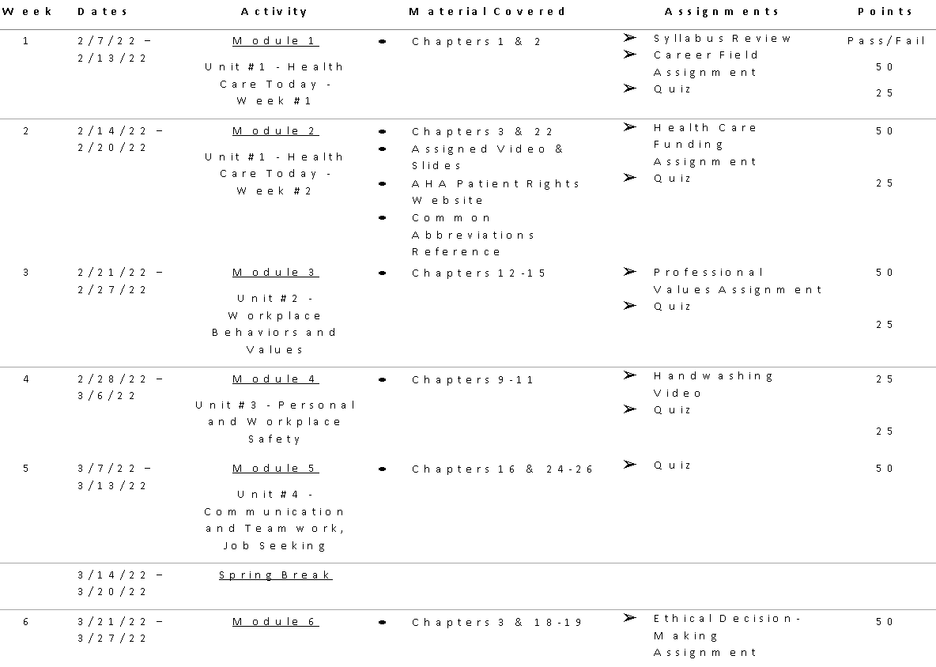

**Attendance:**

{MCCCD attendance regulations are outlined in [MCCCD Administrative Regulation 2.3.2](https://district.maricopa.edu/regulations/admin-regs/section-2/2-3). New instructors should review this prior to establishing an attendance policy.

Faculty have some discretion on the policy they choose to set, but it needs to be clearly stated in this section. Some courses may require rigid attendance rules, others may have more latitude. The sample provided is a fairly rigid example. Nevertheless, it is provided because, in general, the more rigid the attendance policy, the more it will need to be explained in detail. This sample illustrates that well. But again, please don’t feel obligated to mirror the sample provided. It simply serves to illustrate the type of information to provide, not the policy the instructor should set.

**Sample:** Attendance in lecture is mandatory and necessary for adequate performance in the class. Instruction begins on the first day of class. An attendance sheet will be circulated at the beginning of each class. Non-excused absences totaling a week of consecutive lectures or two or more consecutive lab meetings may result in your withdrawal from the class or a failing grade for the semester. If you wish to withdraw from the class, it is your responsibility to initiate a withdrawal. Failure to do so may result in a failing grade for the semester. Official absences are referenced in the [Maricopa Administrative Regulation 2.3.2](https://district.maricopa.edu/regulations/admin-regs/section-2/2-3). All other absences will be considered unexcused absences.}

**Required Materials & Technologies**

1. Students must have access to their student email account. Official school email communication will only be sent to your student email account. This account can be accessed from any web-enabled computer or by a smartphone. For assistance accessing or setting up email tools, contact the student helpdesk (information below).
2. Students may be required to have access to a computer to complete some learning activities and assignments. Computer labs are available on campus at a variety of locations and computer workstations are also available to student in the library
3. Students may be required to complete learning activities or assignments using software such as word processors, spreadsheets, etc. Students have access to both Google Workspace and Microsoft Office 365 at no cost during periods of enrollment through their student accounts. For assistance accessing these tools, contact the student help desk (information below).
4. To complete assignments you may be asked to work with a variety of online digital tools. Some that may require you to sign-up for FREE accounts.

**Tutoring:**

The Learning Center offers tutoring and related services to actively enrolled students. They can offer assistance on a wide variety of subjects. Students are strongly encouraged to become familiar with the Learning Center and take advantage of all their available services. For more information on the Learning Center, visit their website at<https://www.gatewaycc.edu/learning-center>.

**Student Help Desk:**

GateWay Community College students can request I.T. support for the following types of technical support issues:

* Canvas technical issues (e.g. unable to log in, unable to find classes, guidance and referral to Pearson/McGraw Hill etc.)
* Account Password Reset & Duo Authentication
* Internet Connectivity (e.g. guiding students through steps to connect their personal devices to College WiFi and basic troubleshooting)
* Learning Center & Library Applications (e.g. guiding students through steps to download and install Microsoft Office 365)

To request support - please:

* Submit a ticket at <https://maricopaccd.sysaidit.com/servicePortal/submitIncident>
* Call us at 602-286-8413 x6 or 24 hours at 888-994-4433
* Email us at [https://www.studenthelpdesk@gatewaycc.edu](mailto:studenthelpdesk@gatewaycc.edu)
* Visit us at <https://www.gatewaycc.edu/student-help-desk>

**Counseling Services:**

Counseling Services at GateWay offers free, confidential individual counseling for academic, career, and personal concerns to currently enrolled students. Services are offered at the Washington (MA1300), Central City, and Deer Valley campus locations. Connections with community resources and referrals are also available. For contact information, or to schedule an appointment, please refer to our website at <https://www.gatewaycc.edu/counseling> or call us at 602-286-8900 (Washington), 602-238-0040 (Central City) or 602-392-5977 (Deer Valley).

**Key College Policies:**

**Accommodations for Students with Disabilities**

 In accordance with the Americans with Disabilities Act, the Maricopa County Community College District (MCCCD) and its associated colleges are committed to providing equitable access to learning opportunities to students with documented disabilities (e.g. mental health, attentional, learning, chronic health, sensory, or physical). Each class/term/semester that a student is in need of academic adjustments/accommodations, the qualified student is required to work with the Disability Resources & Services Office (DRS) at their individual college(s). Contact with the DRS should be made as soon as possible to ensure academic needs are met in a reasonable time. New and returning students must request accommodations each semester through DRS Connect online services. To learn more about this easy process, please contact your local DRS office.

If you have not yet established services through DRS, but have a temporary health condition or permanent disability that requires accommodations, you are welcome to contact DRS by using the information listed on our website: <https://district.maricopa.edu/consumer-information/disability-resources/contacts>.  The DRS offers resources and coordinates reasonable accommodations for students with disabilities and/or temporary health conditions qualifying for accommodations/academic adjustments.  Reasonable accommodations are established through an interactive process between you, your faculty, and DRS; and only those academic adjustments/reasonable accommodations granted by the DRS are recognized by the college and District.  It is the policy and practice of the MCCCD to create inclusive and accessible learning environments consistent with federal and state law.

**Addressing Incidents of Sexual Harassment/Assault, Dating/Domestic Violence and/or Stalking**

In accordance with Title IX of the Education Amendments of 1972, MCCCD prohibits unlawful sex discrimination against any participant in its education programs or activities. The District also prohibits sexual harassment—including sexual violence—committed by or against students, District employees, and visitors to campus. As outlined in District policy, sexual harassment, dating violence, domestic violence, sexual assault, and stalking are considered forms of "Sexual Misconduct" prohibited by District policy.

**Student Responsibilities:**

Students are responsible for being familiar with all the college policies outlined in the GateWay college catalog & student handbook. These can be found online at: <https://www.gatewaycc.edu/catalog>.

**Academic Honesty/ Integrity:**

Besides academic performance, students should exhibit the qualities of honesty and integrity. Every student is expected to produce his/her original, independent work. Any student whose work indicates a violation of the MCCCD Academic Misconduct Policy including cheating, plagiarism, and dishonesty will be subject to disciplinary action. Refer to the GWCC Student Handbook for information regarding Academic Misconduct and due process procedures.

Academic Misconduct (per GWCC’s Student Handbook, available online at: <https://www.gatewaycc.edu/catalog>)

1. Academic Misconduct - includes any conduct associated with the classroom, laboratory, or clinical learning process that is inconsistent with the published course competencies/ objectives and/or academic standards for the course, program, department, or institution. Examples of academic misconduct include, but are not limited to: (a) cheating and plagiarism (including any assistance or collusion in such activities, or requests or offers to do so); (b) excessive absences; (c) use of abusive or profane language; and (d) disruptive behavior.
2. Cheating is any form of dishonesty in an academic exercise. It includes, but is not limited to, (a) use of any unauthorized assistance in taking quizzes, tests, examinations, or any other form of assessment whether or not the items are graded; (b) dependence upon the aid of sources beyond those authorized by the faculty member in writing papers, preparing reports, solving problems, or carrying out other assignments; (c) the acquisition, without permission, of tests or other academic material belonging to or administered by the college or a member of the college faculty or staff; and (d) fabrication of data, facts, or information.
3. Plagiarism is a form of cheating in which a student falsely represents another person’s work as his or her own – it includes, but is not limited to: (a) the use of paraphrase or direct quotation of the published or unpublished work of another person without full and clear acknowledgment; (b) unacknowledged use of materials prepared by another person or agency engaged in the selling of term papers or other academic materials; and (c) information gathered from the internet and not properly identified.
   * Any student found by a faculty member to have committed academic misconduct may be subject to the following academic consequences, based on the faculty member’s judgment of the student’s academic performance
   * Warning - A notice in writing to the student that the student has violated the academic standards as defined in 1.A.
   * Grade Adjustment - Lowering of a grade on a test, assignment, or course.
   * Discretionary assignments - Additional academic assignments determined by the faculty member.
   * Course Failure - Failure of a student from a course where academic misconduct occurs.

**Student Conduct:**

Students are expected to treat instructors and fellow students with respect. Whether communicating in person or online, students are expected to show respect for the viewpoints of others, including those who hold differing perspectives or may disagree with them. Criticizing, ridiculing, insulting, or belittling others will not be tolerated. Also, be mindful of the fact that written communication lacks nonverbal cues that are so much a part of in-person communication. As such, humor or satire can sometimes be misinterpreted in these contexts. Be deliberate and thoughtful in what you write and mindful of missing nuance in what you read.

**Last Day of Attendance Policy:**

Attendance in lecture is mandatory and necessary for adequate performance in the class. Instruction begins on the first day of class. An attendance or electronic roll will take place at the beginning of each class. Non-excused absences totaling a week of consecutive lectures or two or more consecutive lab meetings may result in your withdrawal from the class or a failing grade for the semester. It is your responsibility to initiate a withdrawal from the class. Failure to do so may result in a failing grade for the semester.

**Withdrawing from the Course:**

There are two kinds of withdrawal: student-initiated withdrawal and instructor-initiated withdrawal. You can find the specific withdrawal dates in my.maricopa.edu > Student Center > My Class Schedule > (Course Prefix/Number) > Calendar button under Deadlines. After the last day for student-initiated withdrawal, students may ask instructors to withdraw them. Failing to submit assignments and maintain steady progress will result in withdrawal by your instructor.

**Syllabus Changes:**

All syllabi are subject to minor changes to meet the needs of the instructor, school, or class. Every effort will be made to avoid changing the course schedule, but the possibility exists that unforeseen events will make syllabus changes necessary. Students will be notified in a timely manner of any syllabus changes. Please check your GateWay email (MEID@maricopa.edu) and the Announcements within Canvas often.